­­­

**Name:**Satyam Kumar Singh **Date:25-02-2023**

**College:**National Institute of Technology Patna,Bihar

**Subject:** Assignment

**1. Difference between if-else and switch case?**

**->**Following are factors which makes differentiable if else and switch case:

a.**Check the Testing Expression:** An if-then-else statement can test expressions based on ranges of values or conditions, whereas a switch statement tests based only on a single integer, enumerated value, or String object.

b.**Switch better for Multi way branching:** When [compiler](https://www.geeksforgeeks.org/introduction-to-compilers/) compiles a switch statement, it will inspect each of the case constants and create a “jump table” that it will use for selecting the path of execution depending on the value of the expression. Therefore, if we need to select among a large group of values, a switch statement will run much faster than the equivalent logic coded using a sequence of if-elses. The compiler can do this because it knows that the case constants are all the same type and simply must be compared for equality with the switch expression, while in case of if expressions, the compiler has no such knowledge.

c.**if-else better for boolean values:**If-else conditional branches are great for variable conditions that result into a boolean, whereas switch statements are great for fixed data values.

d. **Speed:** A switch statement might prove to be faster than ifs provided number of cases are good. If there are only few cases, it might not effect the speed in any case. Prefer switch if the number of cases are more than 5 otherwise, you may use if-else too. If a switch contains more than five items, it’s implemented using a lookup table or a hash list. This means that all items get the same access time, compared to a list of if:s where the last item takes much more time to reach as it has to evaluate every previous condition first.

e. **Clarity in readability:**A switch looks much cleaner when you have to combine cases. Ifs are quite vulnerable to errors too. Missing an else statement can land you up in havoc. Adding/removing labels is also easier with a switch and makes your code significantly easier to change and maintain.

**C1->Programmes In JS Language:**

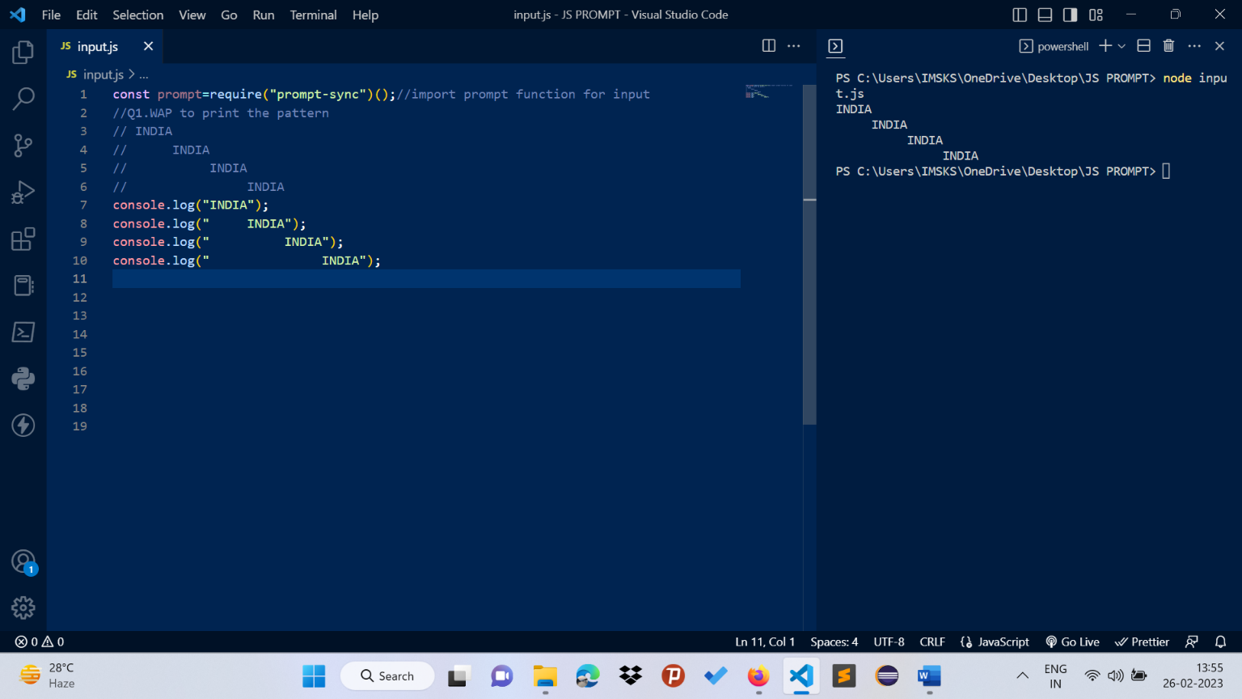

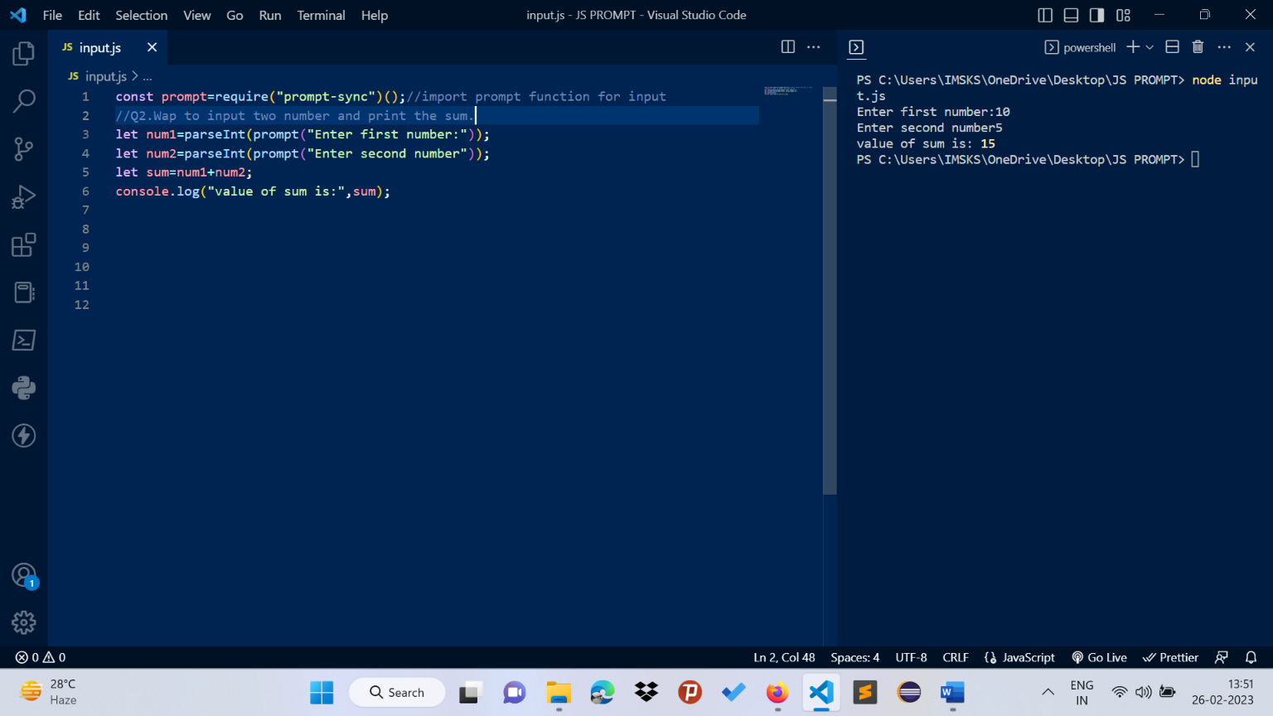

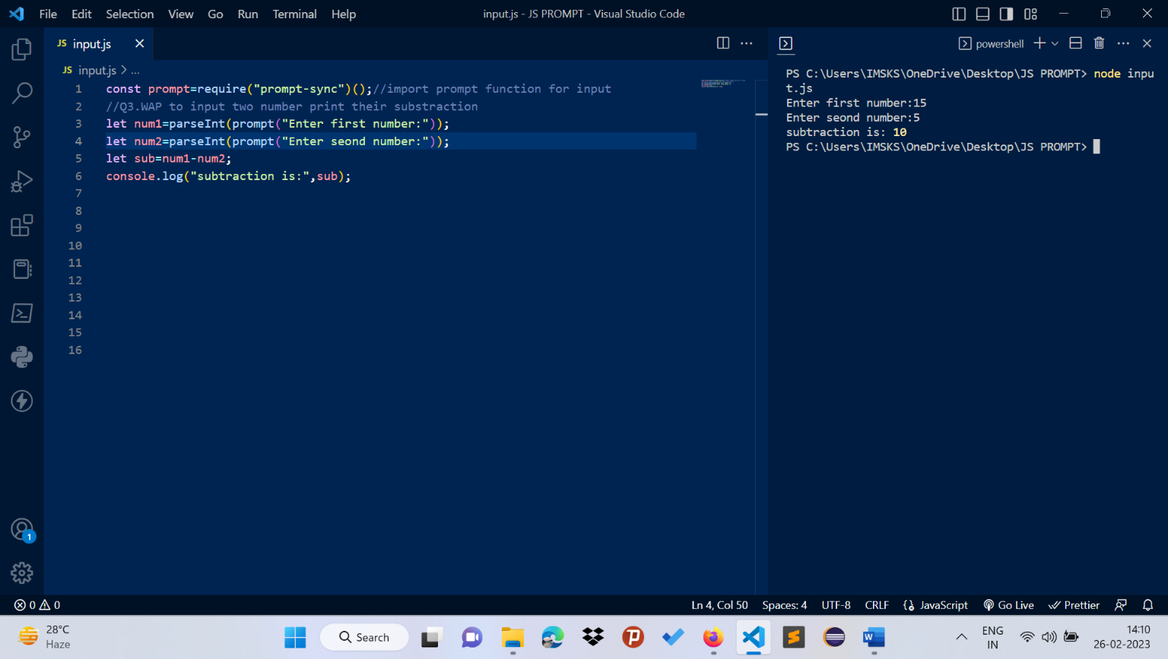

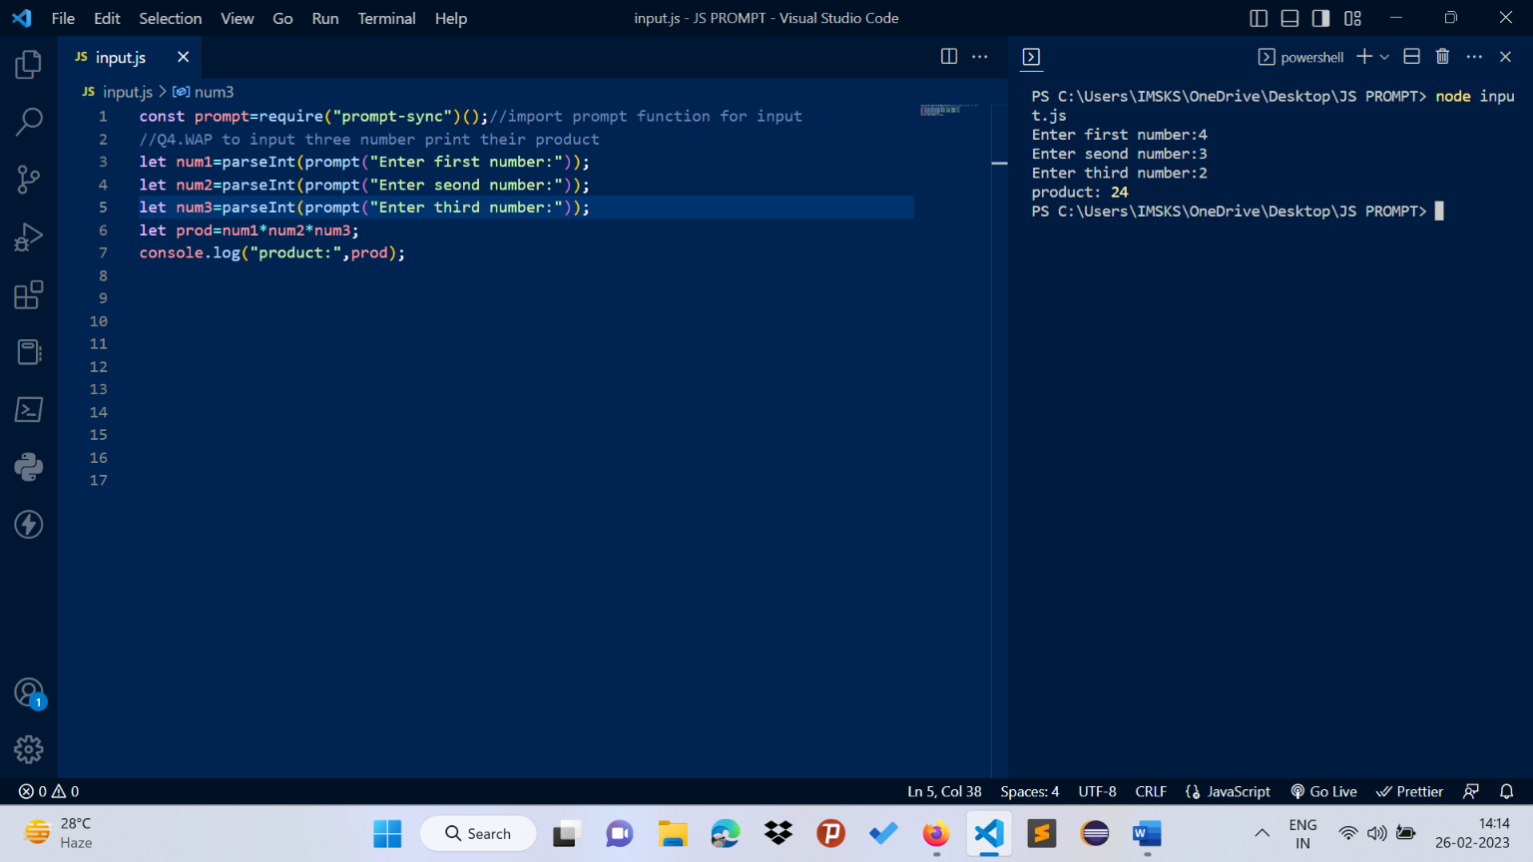

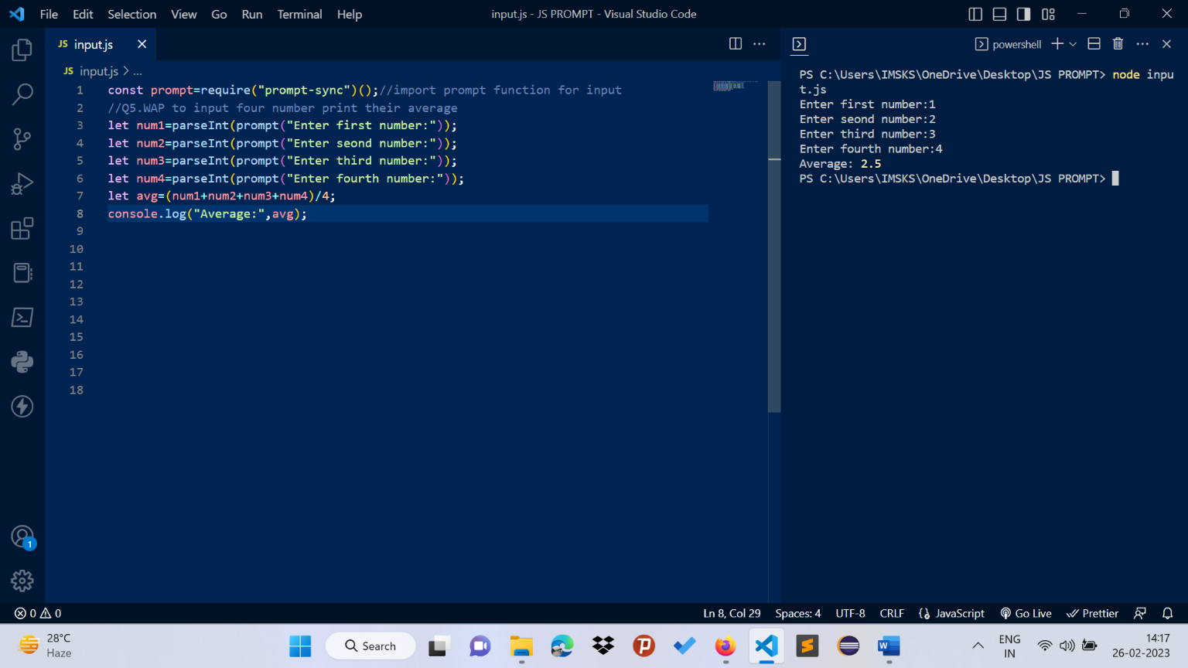

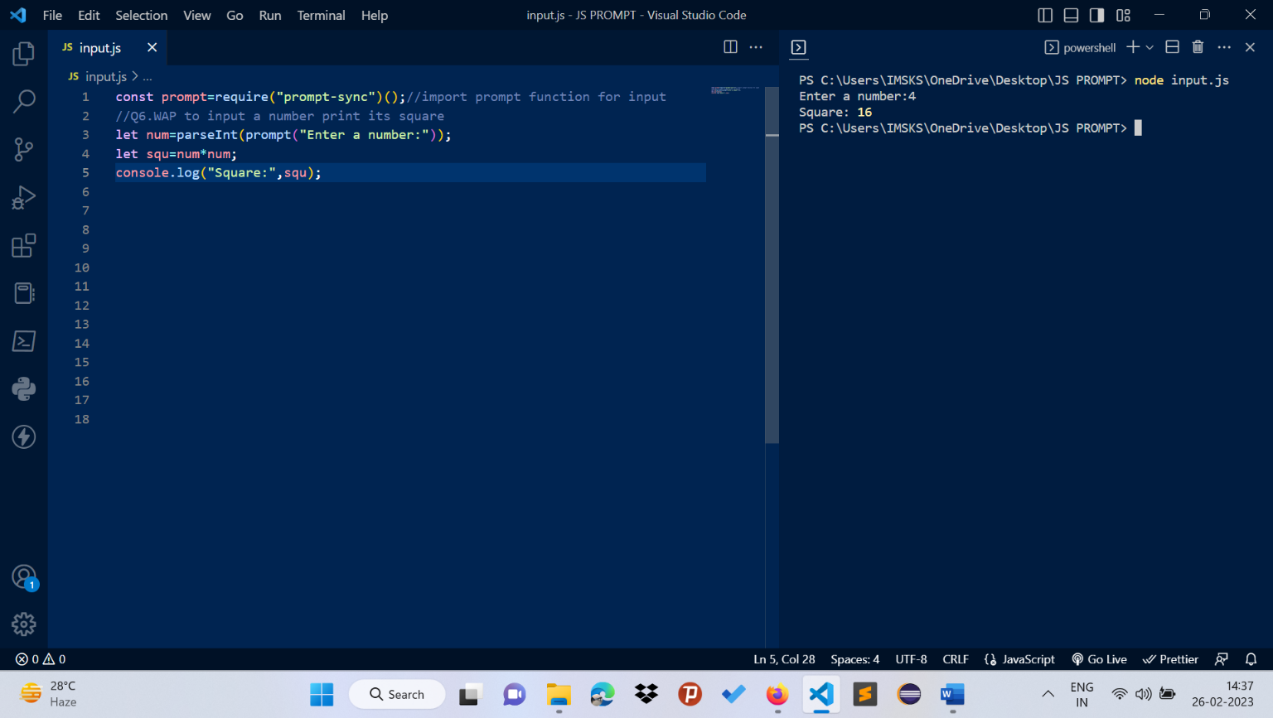

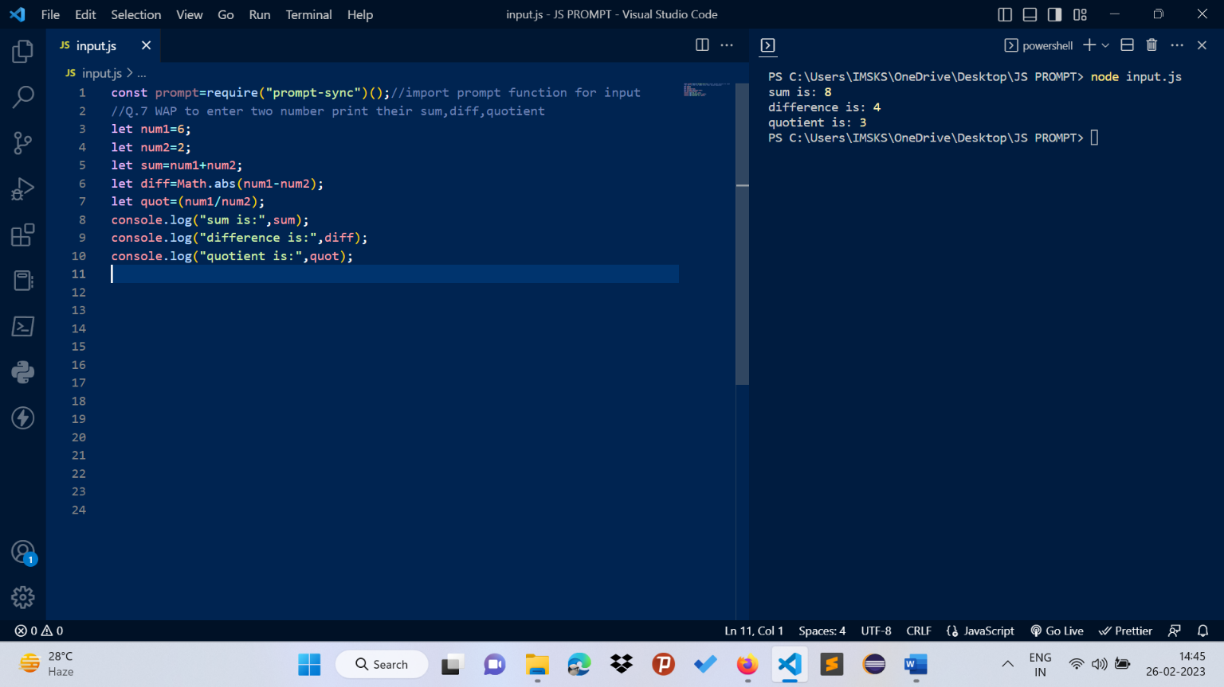

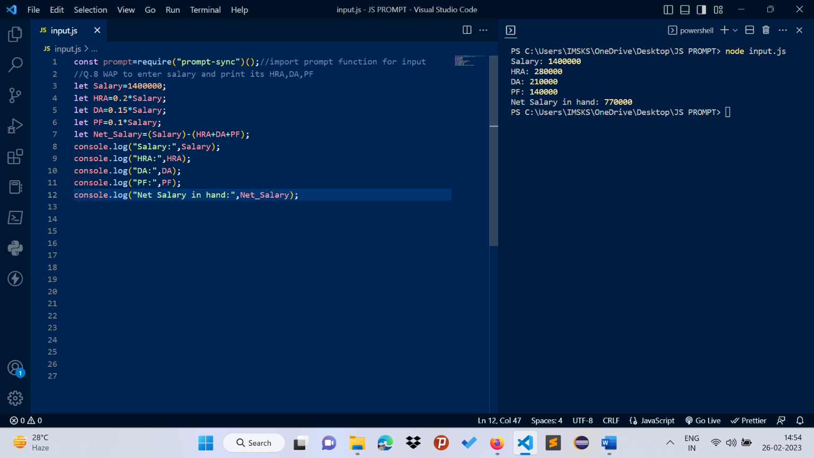

**C2->Programmes in JS languages**

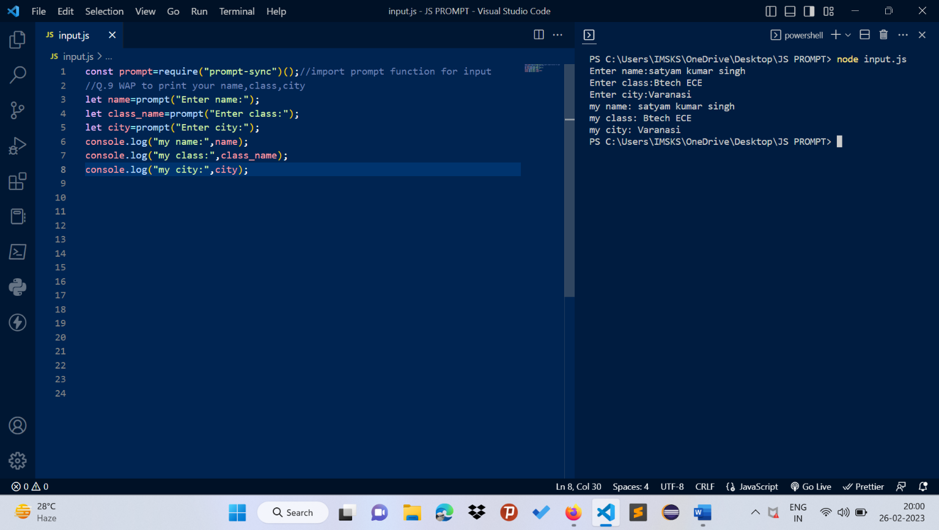

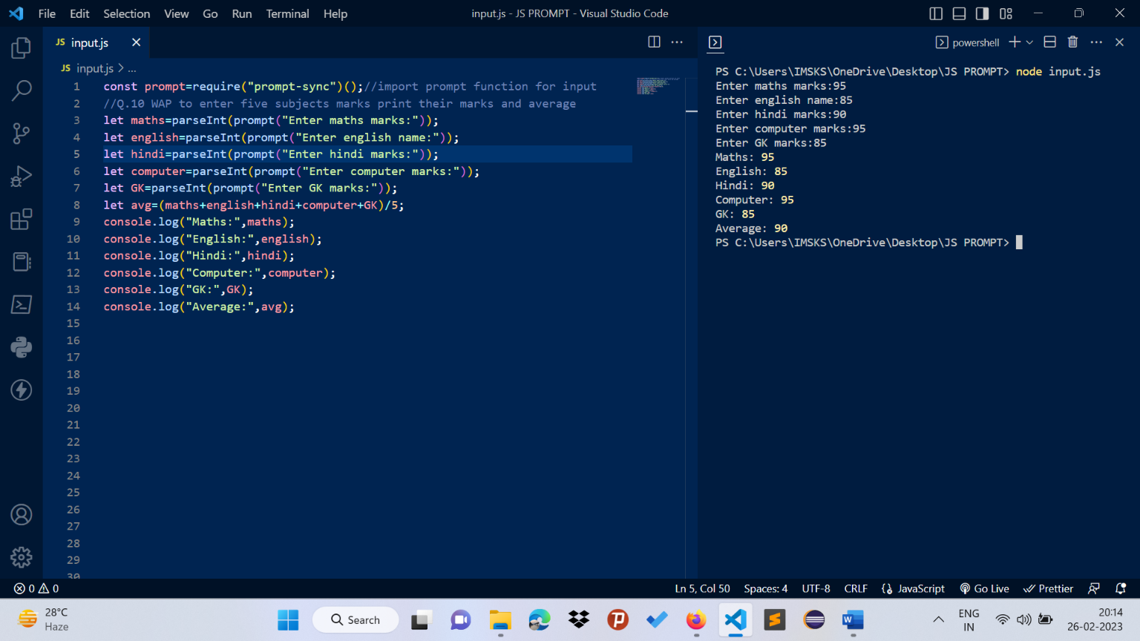

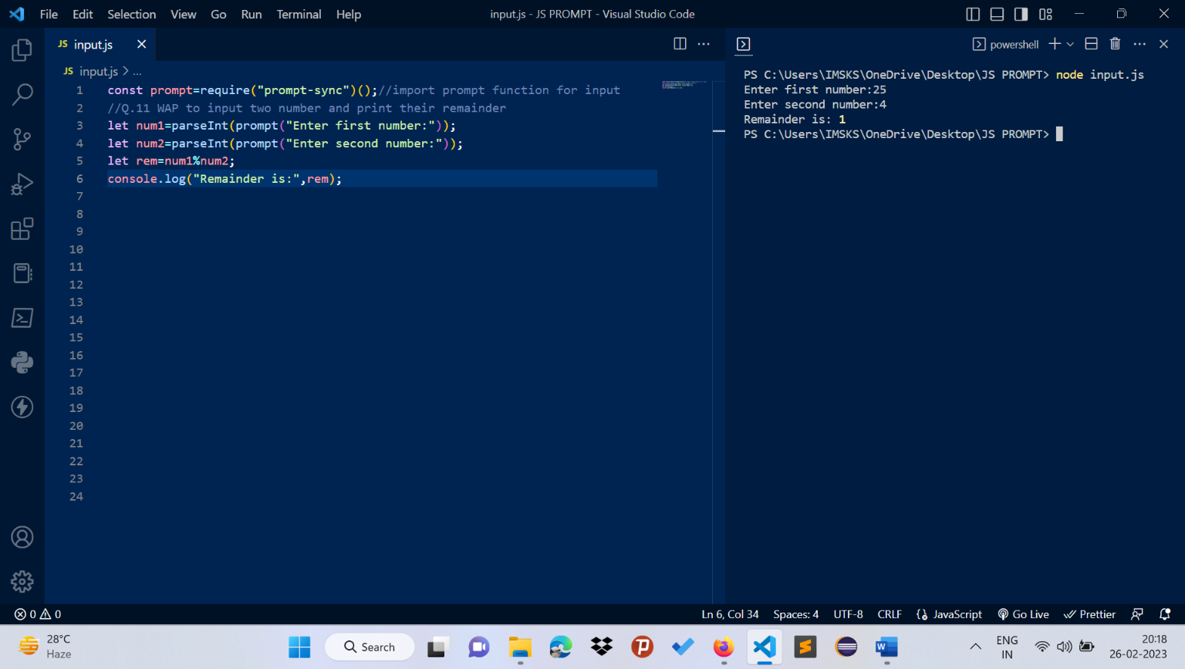

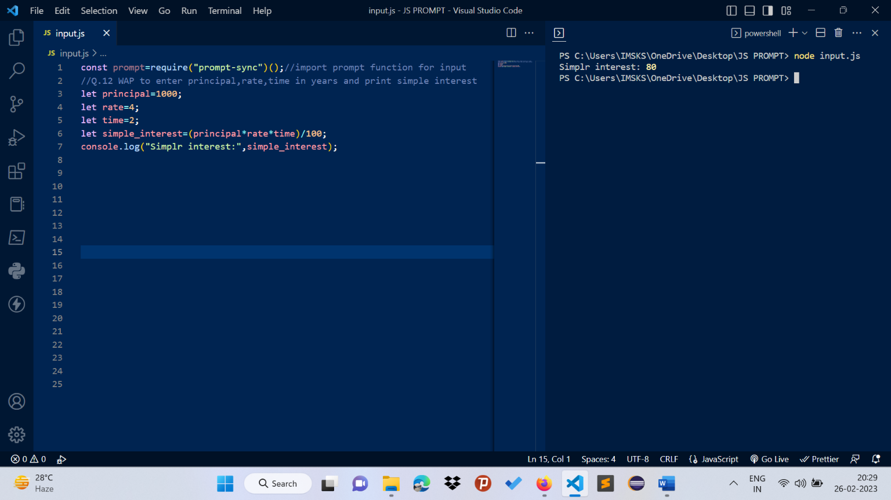

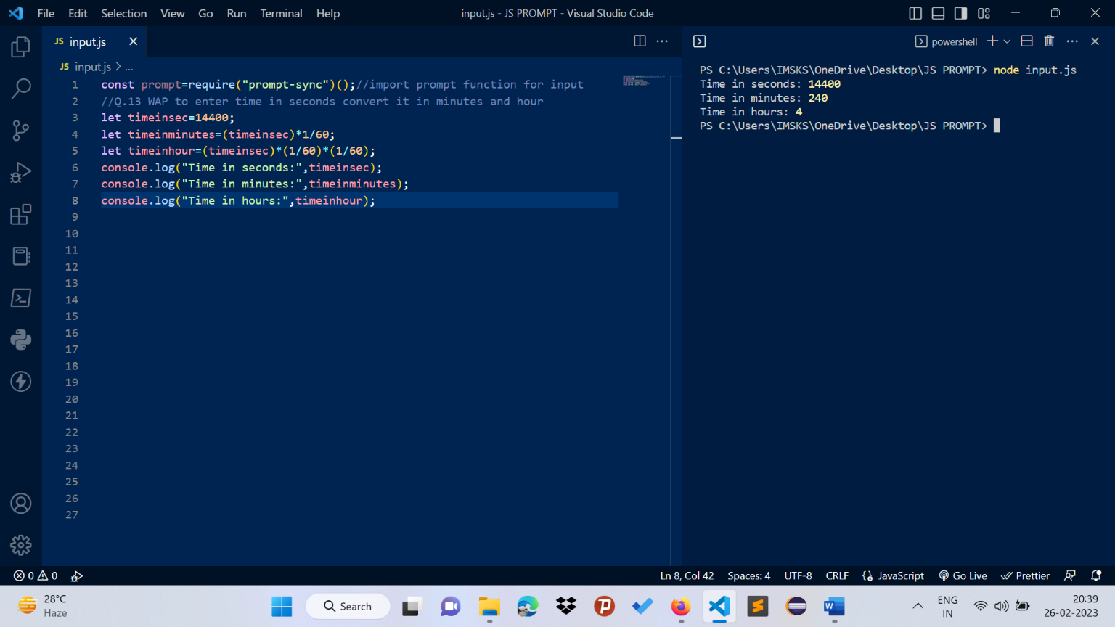

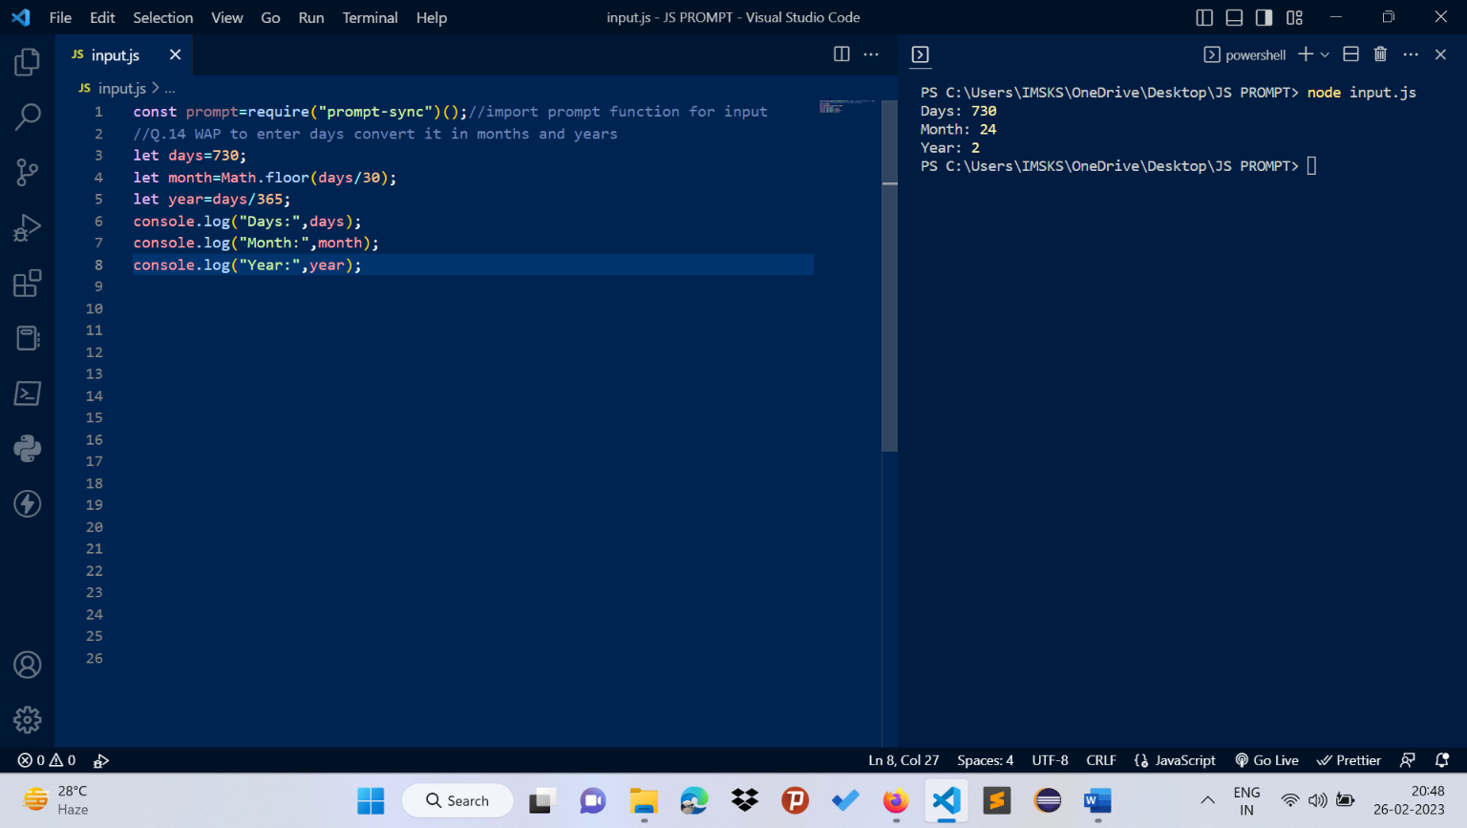

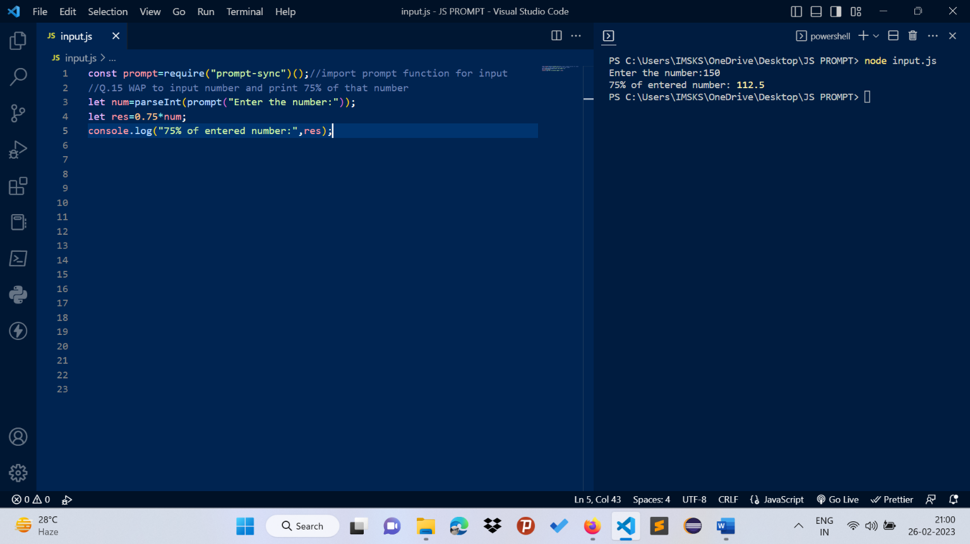

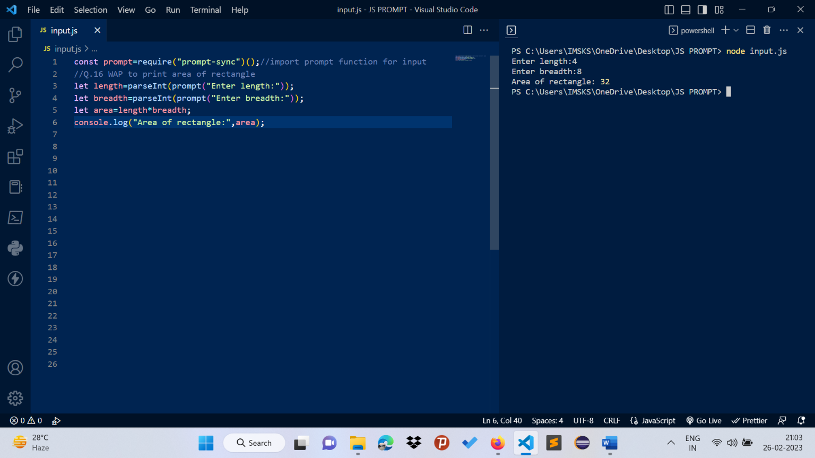

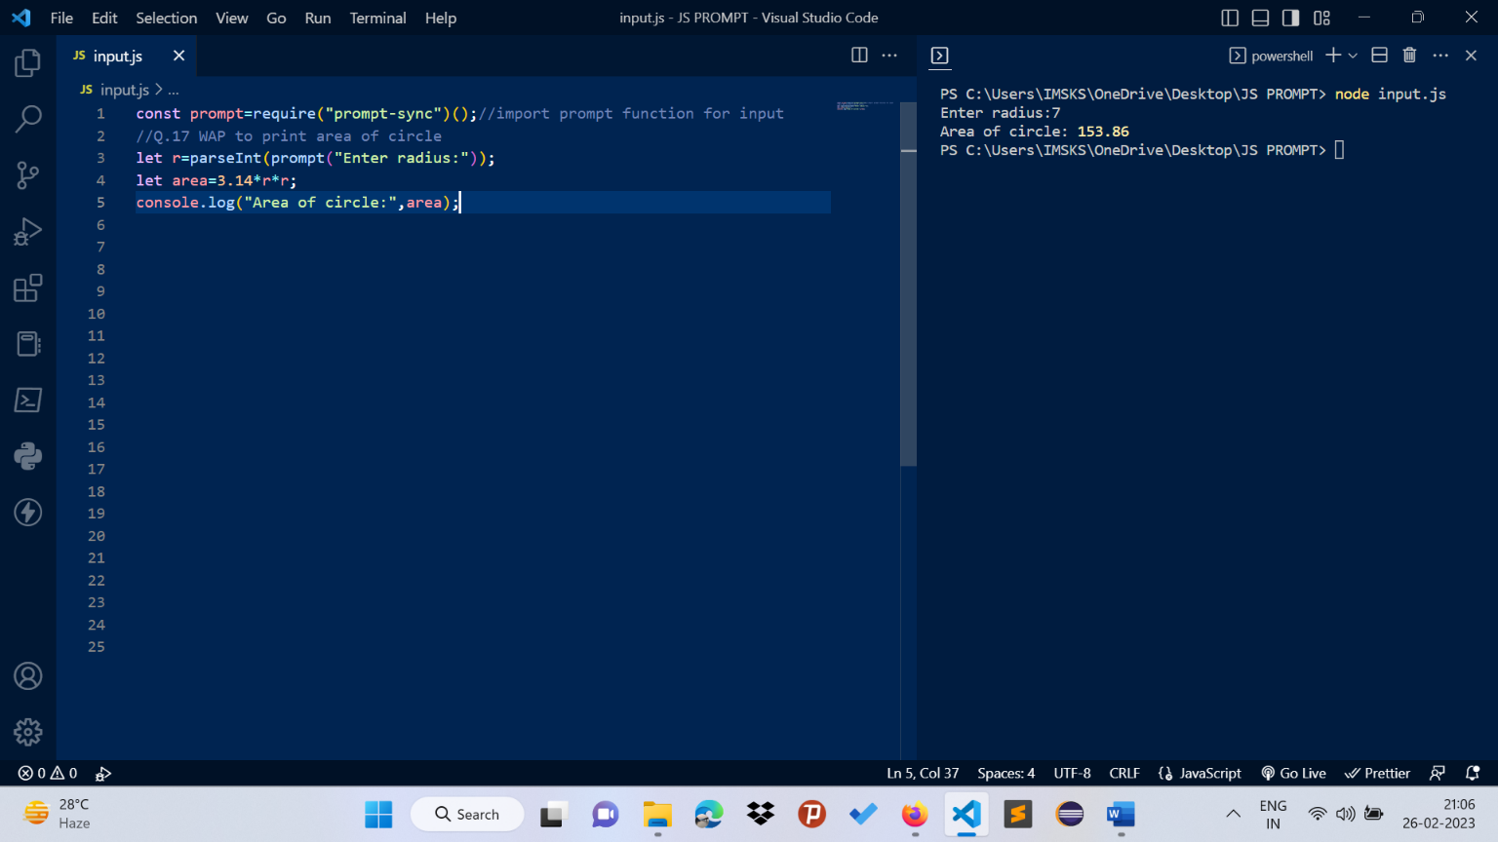

**C3->programmes in JS languages**

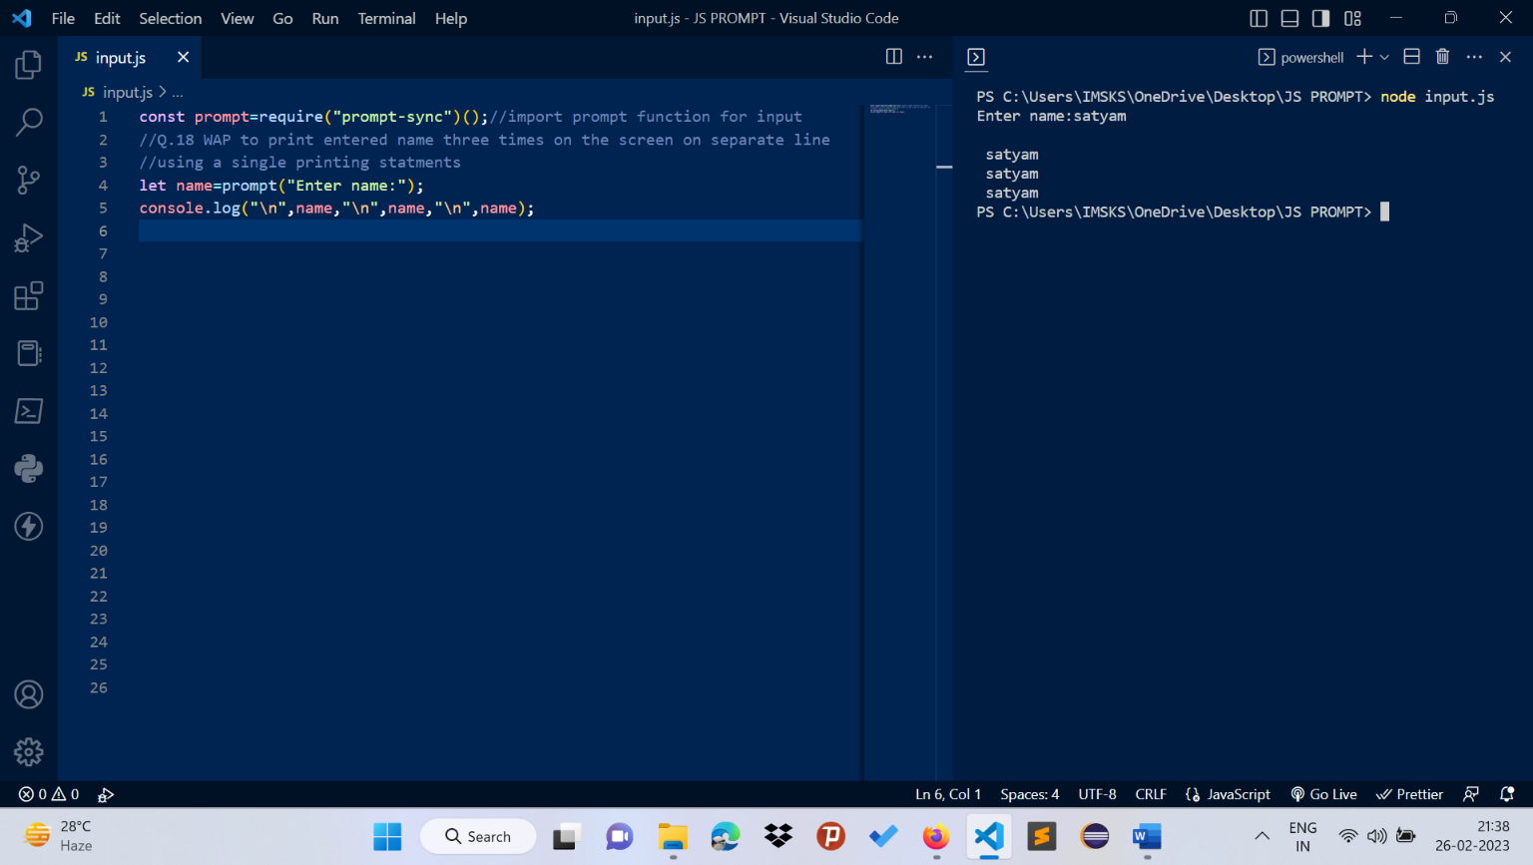

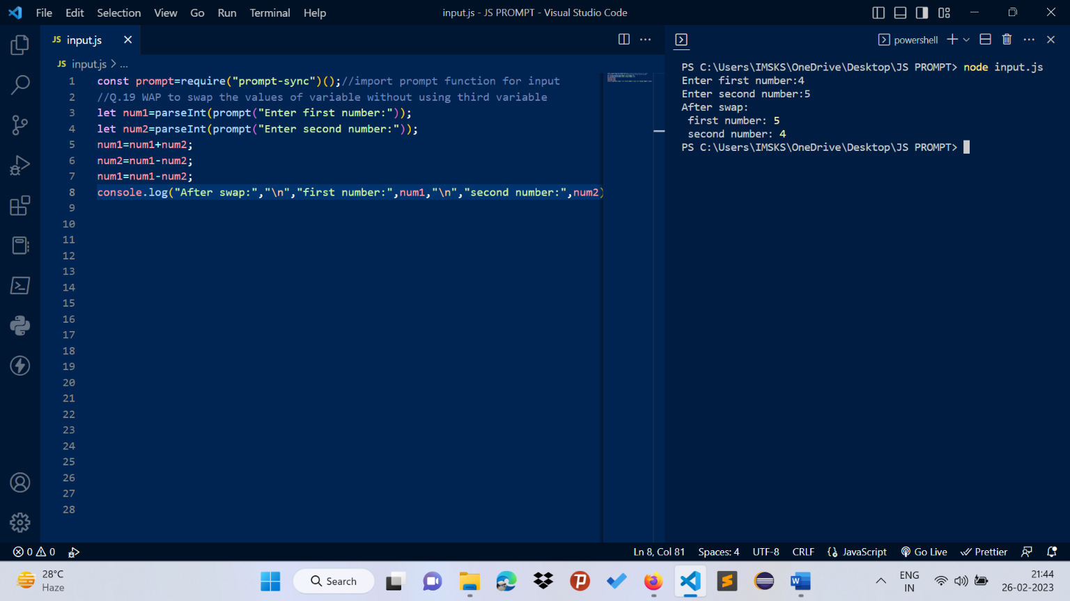

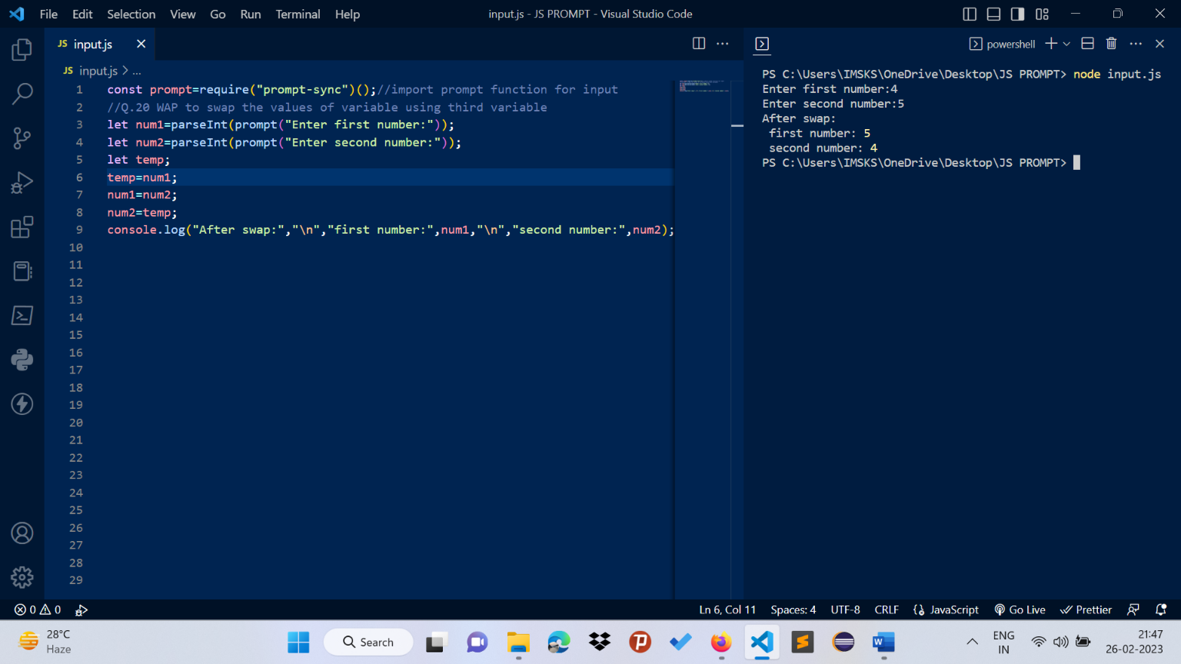

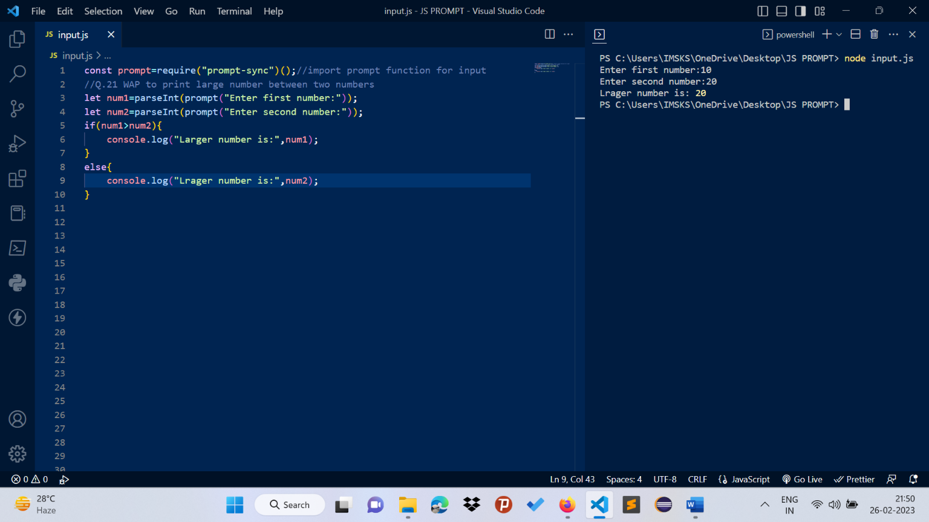

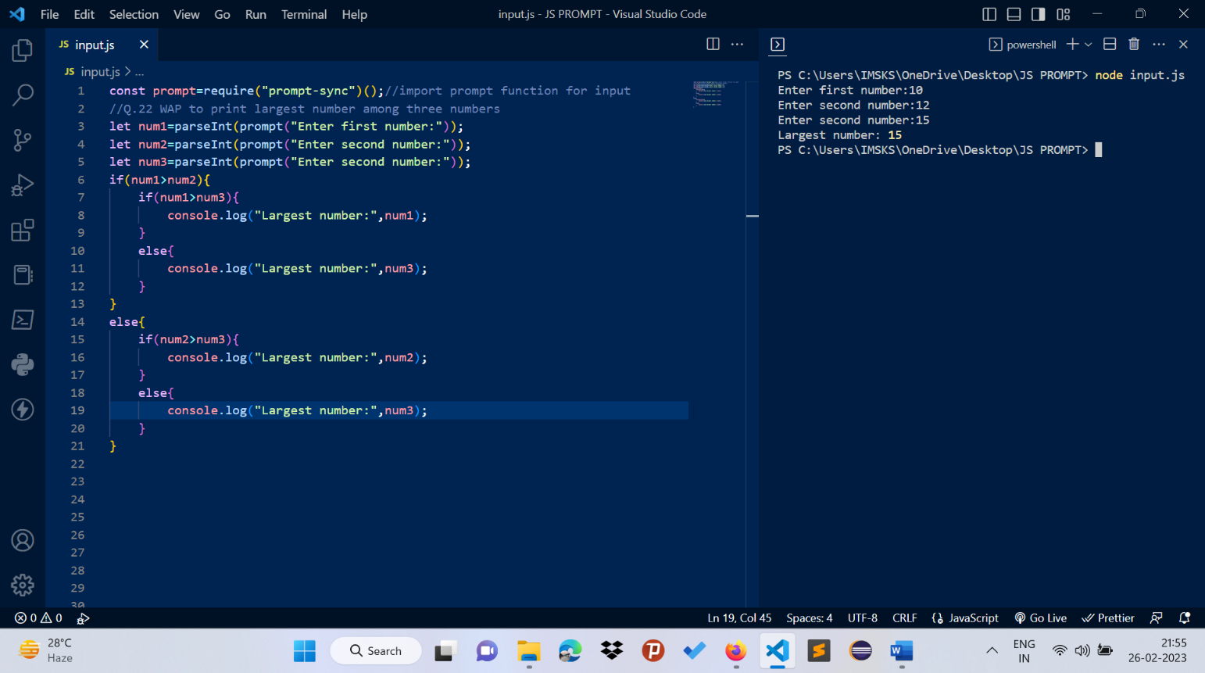

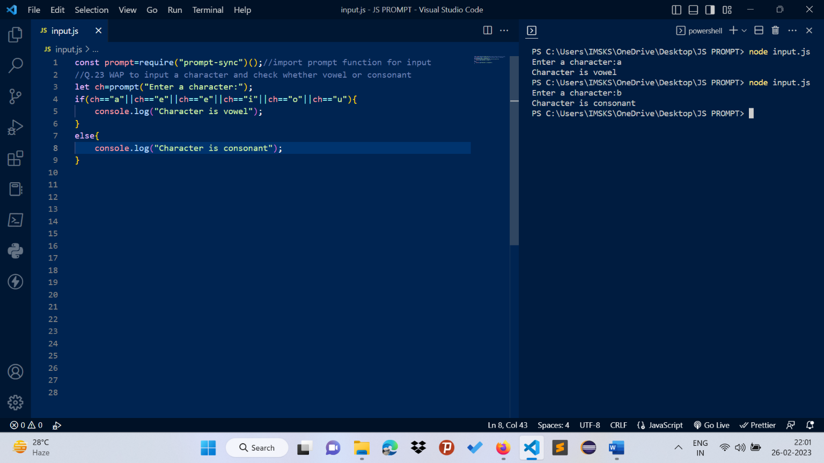

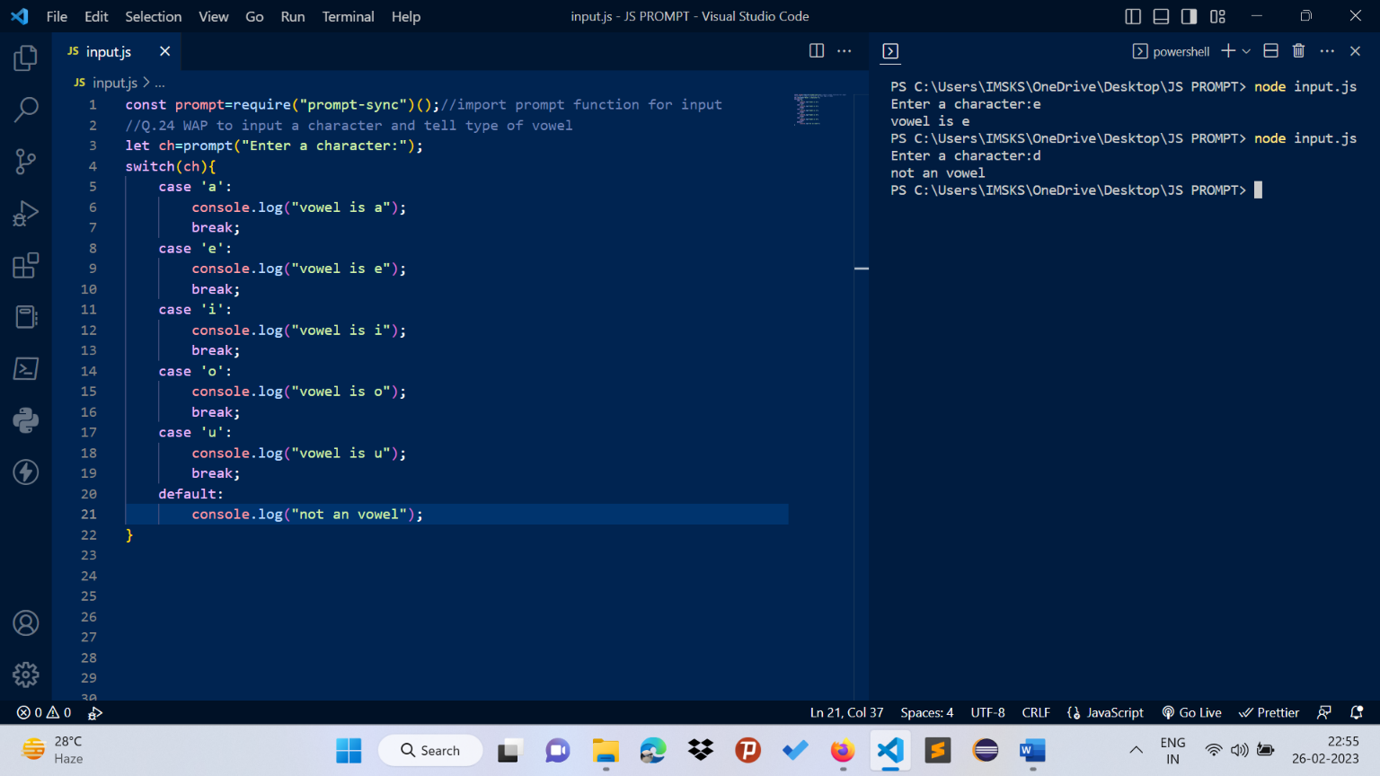

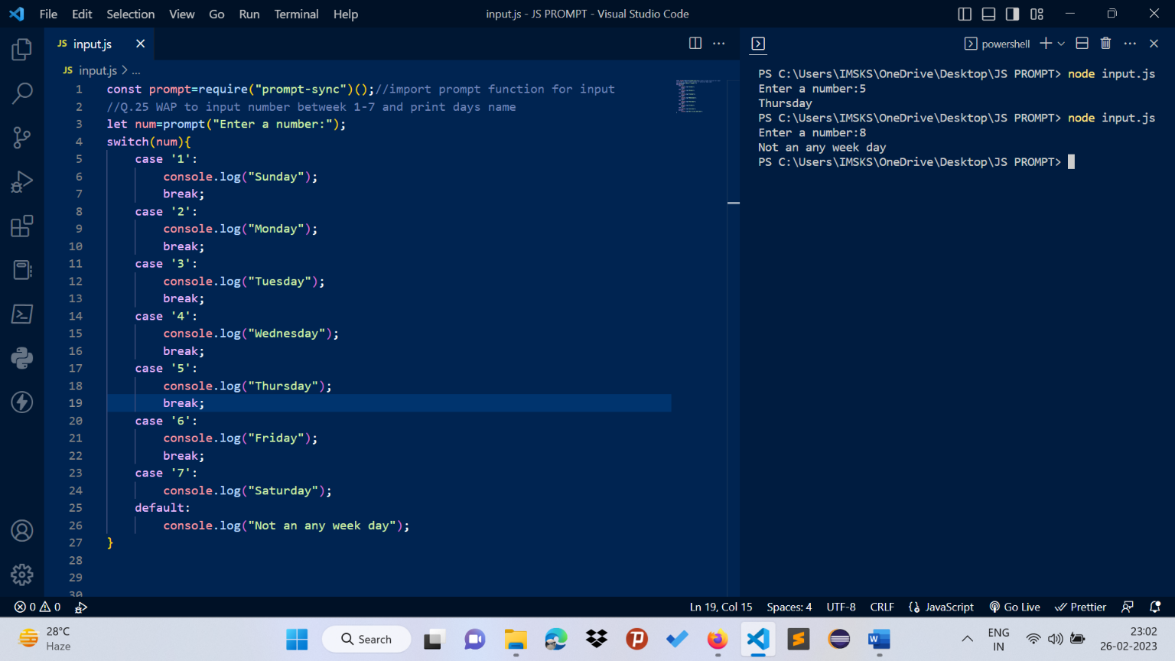

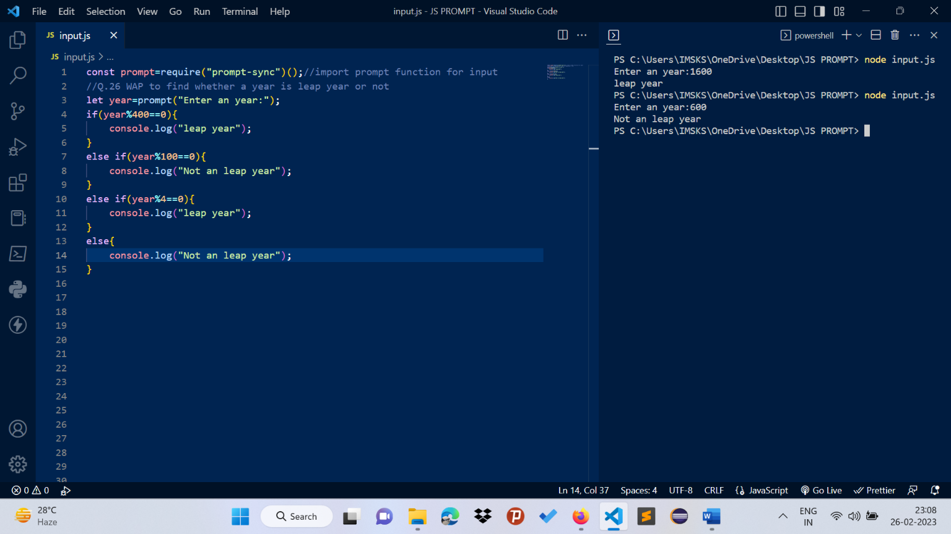

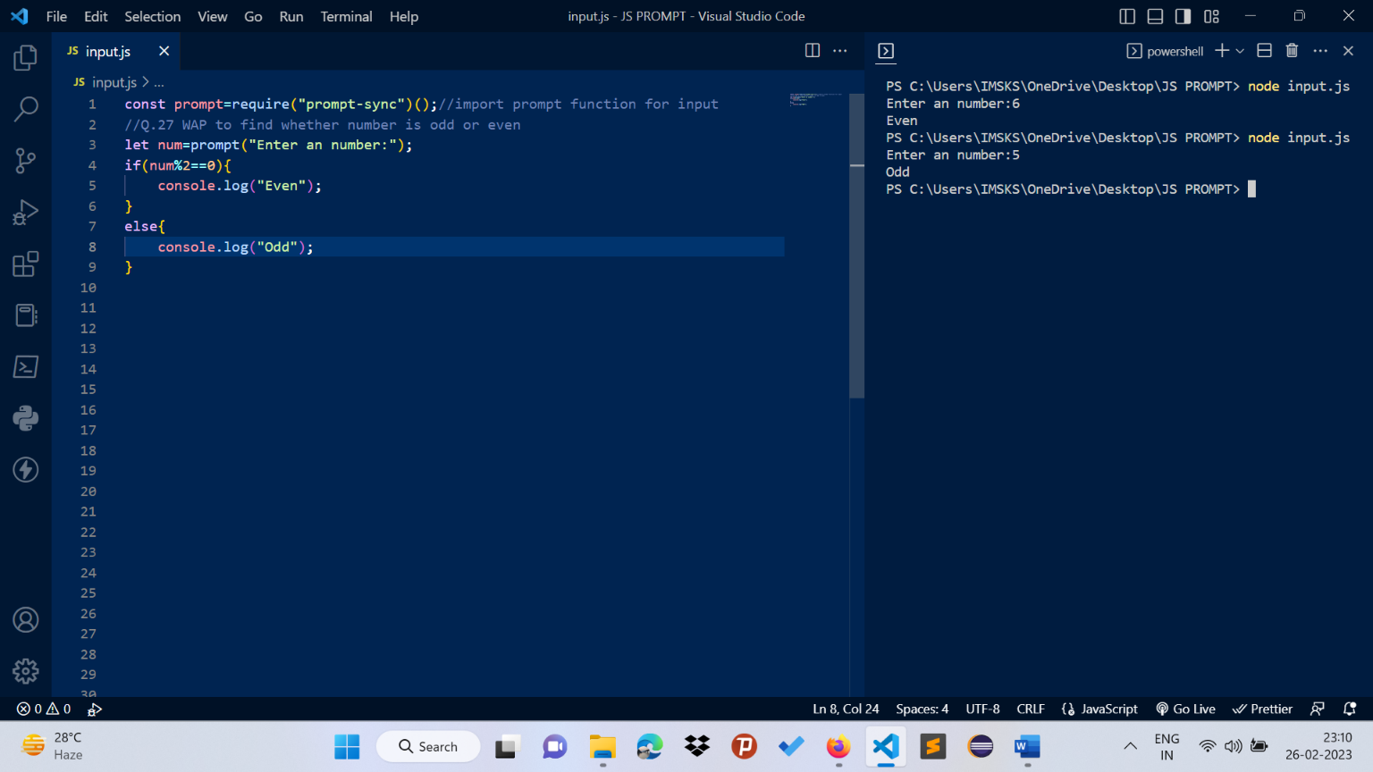

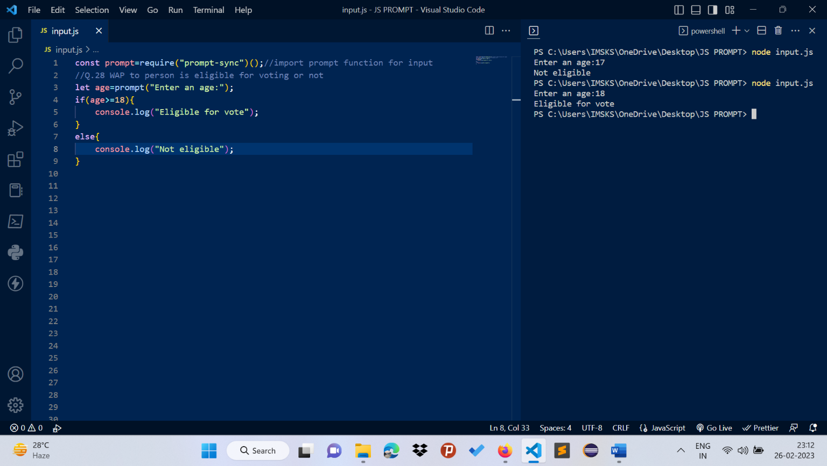

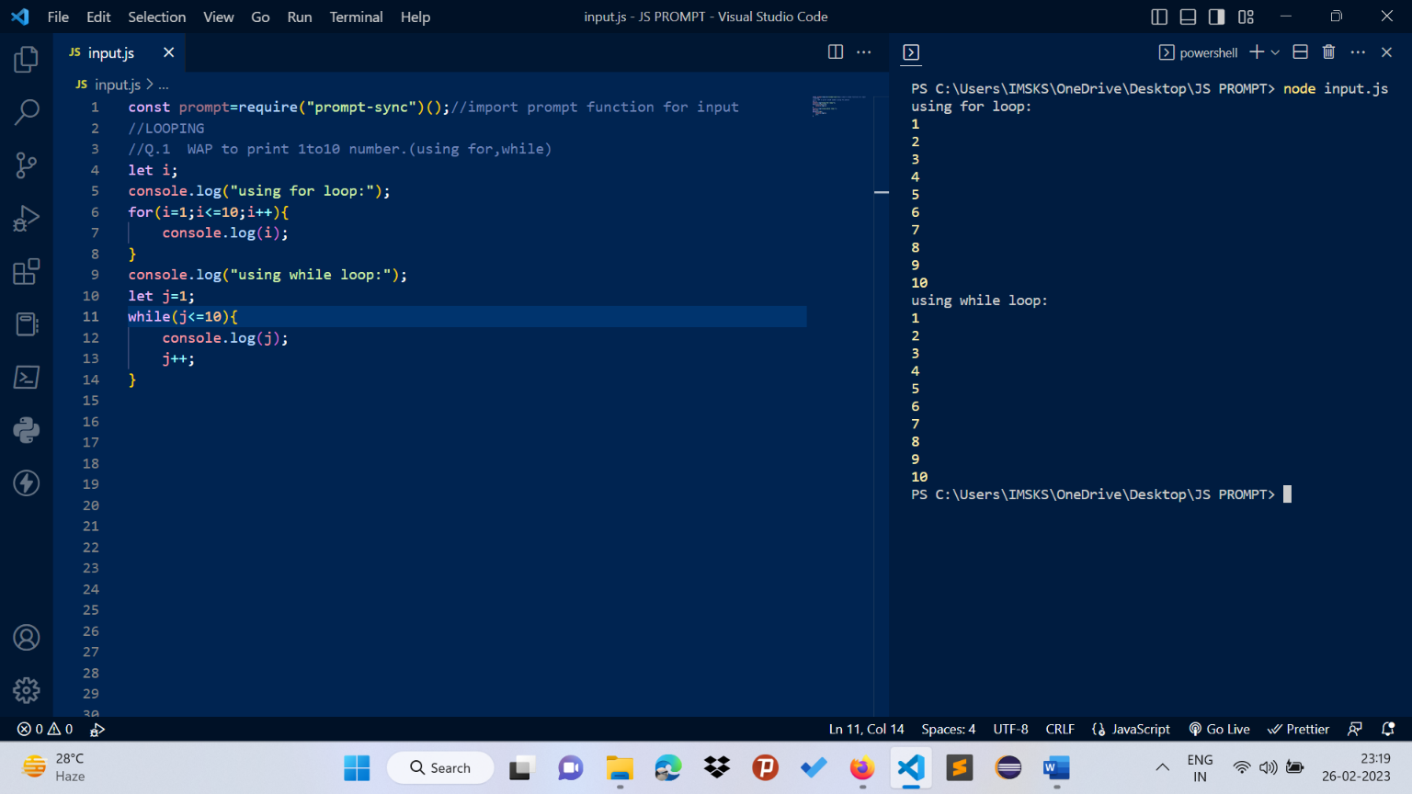

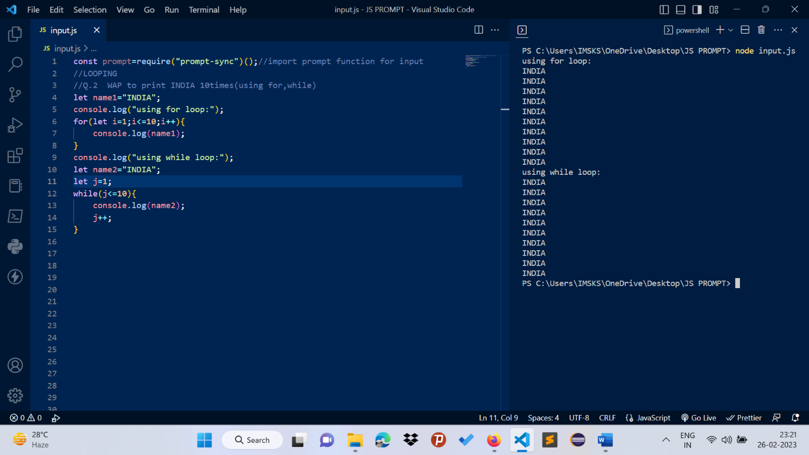

**C3->Programmes in JS languages**

